**Goals Tracking Module Requirements**

This document presents an overview of the Goals tracking module requirements for the site bonus process implementation. The purpose of the module is for the site team to track and follow sales volume versus monthly goals in real-time on a dashboard at the site.

Goal-Tracking Module

The dashboard is a display of the metrics from site sales and operations. There is no user interaction with the application.

Goal-Tracking

The goal-tracking dashboard tracks four metrics.

1. Total Water Volume of sales, including to schools
2. Site Up-time
3. Vehicle Uptime
4. Bonus

There will also be an input of two monthly numbers that will be displayed statically on the dashboard.

1. Monthly Water Volume Goal
2. Monthly Water Volume Bar

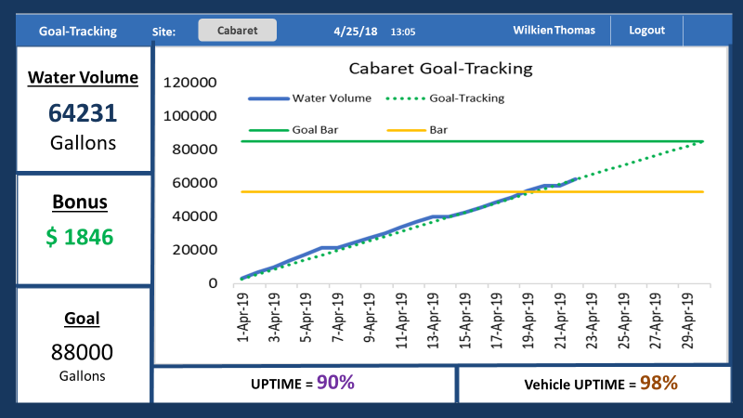The static numbers and tracking metrics will be combined into a graph form. The display will be visualized as seen below:

Calculations of Metrics

To display the correct value for the following metrics the following calculations will be displayed

1. Total Water Volume = Sum (Total Gallons) within the range of the month
2. Site Up-time = Total Uptime/(10 hours per day * Total working days in the month)
3. Vehicle Uptime = Vehicle Uptime/(10 hours per day * Total working days in the month)

The Bonus is a tiered formula based on the level of Total Volume.

1. Bonus Formula

* If Total Volume < Bar, then Bonus = 0
* If Bar < Total Volume < Goal, then Bonus = (Total Volume-Bar)/5
* IF Total Volume>Goal, then Bonus = (Total Volume-Bar)/5 + (Total Volume-Goal)/5*2 + 1000